Create a new Assessment scheme (AS) :->
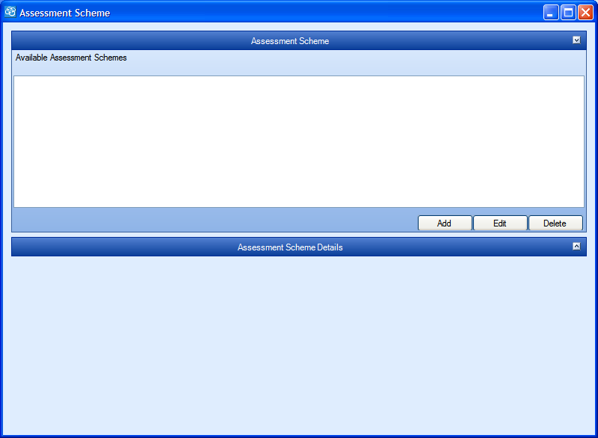

Functionality :->
This form will be useful as welcome screen for assessment scheme master
wizard. It will provide details of the various actions to performed in coming screens.

2.

Functionality :->
This screen helps to select one of the Rating scheme available.
It also provide description of each rating scheme in adjacent
gridview.
Defaultly it must show the description of first Rating scheme ascended alphabetically.

1. Select ant rating scheme from available rating schemes provided in listview box labeled “Available Rating scheme”.
2. Press “Select” button to select that rating scheme for this “Assessment scheme”.

Validation :->

Before moving to next screen atleast one rating scheme should be selected.

2.
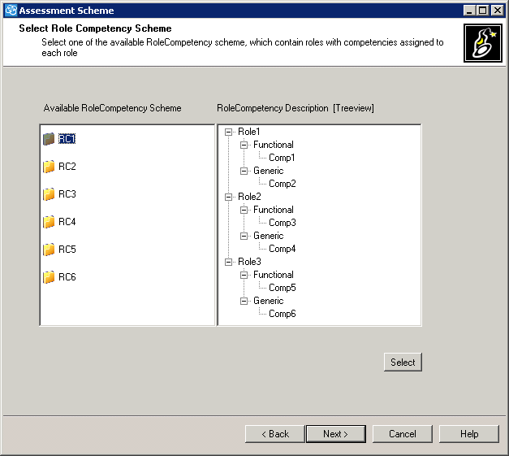

Functionality :->
This screen helps to select one of the RoleCompetency scheme available.
It also provide description of each RoleCompetency scheme in adjacent
Treeview.
Defaultly Treeview must show the description of first RoleCompetency scheme ascended alphabetically.
Treeview should show the entire hierarchy of the RCS including the competency types added to the role and competencies of each type addec to role.

1. Select any RoleCompetency scheme from available RoleCompetency schemes provided in listview box labeled “Available RoleCompetency scheme”.
2. Press “Select” button to select that RoleCompetency scheme for this “Assessment scheme”.
Validation :->

Before moving to next screen atleast one RoleCompetency scheme should be selected.

4.
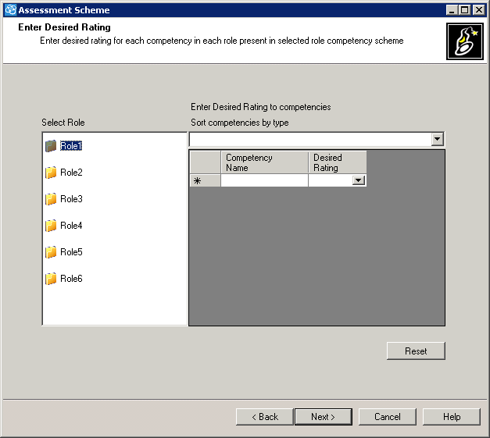

Functionality :->
This screen help to enter the desired ratings for each competency of each role present in selected role competency scheme, with reference to selected rating scheme.
User can sort the competencies of roles by their types for easiness in entering the desired rating.
After selecting any role, Defaultly all competencies must be shown in
gridview without any sort.

1. User should select a role from list box labeling “Select Role”
all competencies alloted to that role will be shown in grid view column named “Competency Name”.
2. Gridview is having second column name called “Desired Rating”, which is

having a combo boxes. These boxes contain rating value referenced from rating scheme. User can select any one of that value as desired rating.
3. If user wants to enter desired rating according to competency type then he should be able to sort with help of combo box provided at top of gridview.

Validation :->
Before moving to next screen every competency of each role must have desired rating.

5.

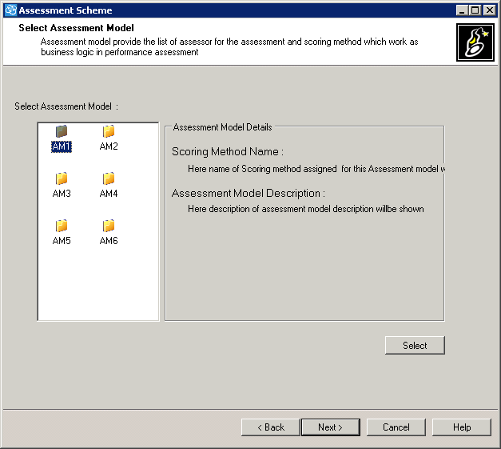

Functionality :->
This screen will be used for selecting already available Assessment model.
This screen shows entire details of Assessment model like it's description and scoring method assigned to it.

1.
user will click on one of assessment model and all it's description
will be displayed in adjacent groupbox.
Defaultly description of first assessment model must be displayed.

Validation :->
before moving to next screen one Assessment model must be selected.

6.

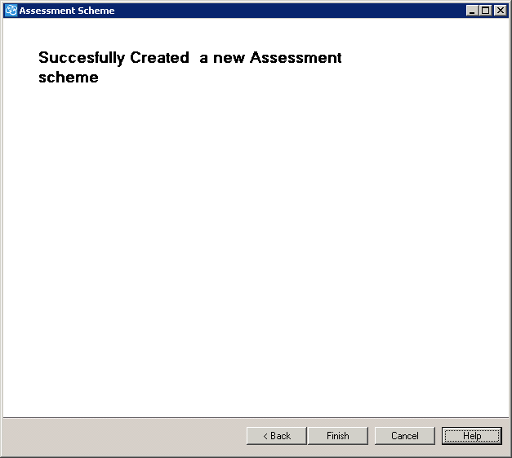

Functionality :->
this screen displays the success message that new Assessment scheme
is successfully created.

